**SCDHS Hotline**

Standard Operation Procedures

2024

Revised: 08.23.2024

Table of Contents

Step by step on how to: ____________________________________ 3

SCDHS Hotline: _____________________________________________ 3

Information needed to request patient’s eligibility status: _______ 4

When Patient’s Eligibility status provided: ____________________ 5

Identify the hospital: ______________________________________ 6

Identify Patient’s Information 7

Identify the date of service: _________________________________ 7

How to send “User Task”: ___________________________________ 8

How to send “User Note”: __________________________________ 11

Patient Queue: ___________________________________________ 13

RS (Resolution Specialist): _________________________ 13

**Step by step on how to:**

1. Use Patient Queue to pull information needed to request patient’s eligibility status.
   1. not needed for SC
   2. Identify patient’s information /use 1716 to identify mother’s info, if no 1716 on file, review “conditions” under personal screen for newborn babies
   3. Identify date of service
   4. Call SCDHS hotline
   5. Obtain eligibility status
   6. Identify RS
   7. Status Agency / send user task

**SC****DHS Hotline:**

Use SCDHS hotline for questions about case status, benefits, services and eligibility. SCDHS hotline can provide eligibility status for three clients per call. SCDHS hotline can escalate cases for corrections of demographics such as DOB or name spelling, as well application type if not being processed correctly.

Call SCDHS Hotline at: **1-888-549-0820**

* Press “1” for English.
* Press “1” for application follow-up.
* Press “1” to get the status of the application.
* Press “1” for application Status OR
* Press “2” to enter SSN or Medicaid ID# or stay on the line for a representative.
* Once hotline representative answers the call:
  + “Good Morning/Afternoon, my name is (first name) calling from Optum/Change Healthcare to follow up on a status of an application.”
* SCDHS representative can provide status for three patients in each call.
* SCDHS representative will ask for information that will help in finding the client’s eligibility. Please refer to “Information needed to request patient’s eligibility status” section for more information.
  + Provide as many information as needed to find client in SCDHS system.
  + For minor children, provide guardian’s information as well as the child.
* Have all needed information available when calling hotline as SCDHS representative has limited time and will not wait/assist if the information is not presented at the time of the call.

**Information needed to request patient’s eligibility status:**

* Adult
  + Social security number or Medicaid ID
  + Date of birth
  + Name
  + Address
  + Phone number
  + Application tracking number
  + Date of service
* Minor
  + Parent’s social security number or Medicaid ID
  + Parent’s date of birth
  + Parent’s name
  + Address
  + Phone number
  + Child’s name
  + Application tracking number
  + Date of service

**Additional questions to ask when:**

* If case was approved:
  + Obtain the Medicaid ID #
  + Eligibility start date
  + Date application was approved
* If case was denied:
  + Obtain Denial reason
  + Obtain denial date
  + Verify if any other application is pending
    - If yes, what is the application date.
  + If reason for the denial is excess income and/or resources verify the amount of income and/or resources found by the DHHS
* If case was not found/canceled:
  + Obtain cancelation reason
  + Obtain cancelation date
  + Verify in any other application is pending
    - If yes, what is the application date.

**When Patient’s eligibility status provided:**

1. Update PACE
   1. Case Pending:
      * 1. Date of application
        2. Status of the application
   2. Case Not Found/Canceled:
      1. Send “User Task” to RS with detailed message:
         1. Application date
         2. Status of application
         3. Patient’s eligibility status
   3. Case Denied:
      1. Send “User Task” to RS with detailed message:
         1. Application date
         2. Status of application
         3. Denial date (if provided)
         4. Denial reason (if provided)
         5. Patient’s eligibility status
   4. Case Approved:
      1. Send “User Task” to RS with detailed message:
         1. Eligibility status
         2. Medicaid ID #
         3. Coverage range dates
         4. System Date/Date Coverage was Approved
   5. If case is approved but needs a backdate (doesn’t cover our DOS)
      1. Provide future dates to obtain Medicaid ID.
      2. Example: DOS (admit-to-discharge dates) is 5/8/19-5/10/19; SCDHS Representative stated, “not eligible for DOS and case needs to be backdated”. User should provide SCDHS representative DOS for future months (7/819,8/8/19,9/8/19) to obtain Medicaid ID.

**\*\*Important\*\***

* Please review the case history prior to sending a user task. If a status was obtained and user task was previously set and subsequently marked as “completed” by the CHC Onshore team DO NOT set additional User Tasks for the same status. A “user note” should still be placed into the system following the above guidelines. However, additional language should be included: “previous task marked as completed, no additional tasks will be set at this time”.

**How to Identify a “Completed” user task**

On the left-hand side of PACE locate “view history” and click it

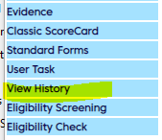

* You should then be able to identify when your user task was submitted and when it was completed by the On Shore team by looking for these key items:
* Under Activity – it will say user task under activity but there will be no results – this should indicate the user task that was sent to another user
* When the On-Shore team addresses that task, it will say “contact initiated” under result



Additionally, when you hover over the sticky note, it will show the status as well as the user that assigned the task. If the status is marked as “completed” and the update being placed in the system is identical to the completed task, do NOT place another task, only a note.

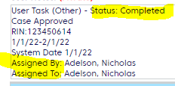

**Identify the hospital**

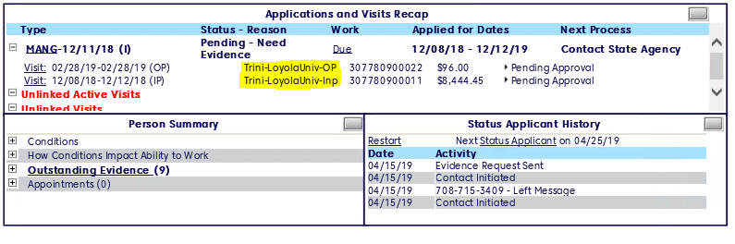

**Identify patient’s information**

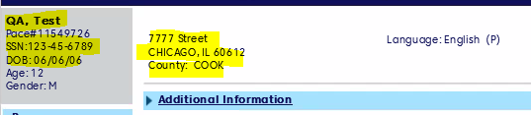

**Identify the date of service**

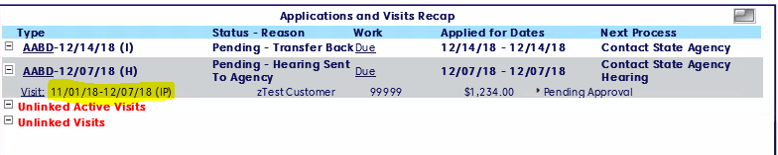

**How to send “User Task”:**

1. Click on “User Task”

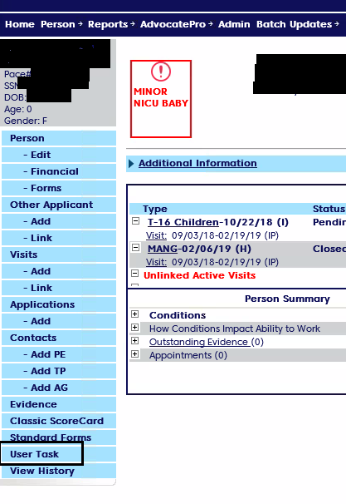

1. Under “*User*” type assigned RS name
2. Under “*Detai*l”, include your detailed note
3. Mark the “*priority*” as:
   1. “*High*”-for approved or denied

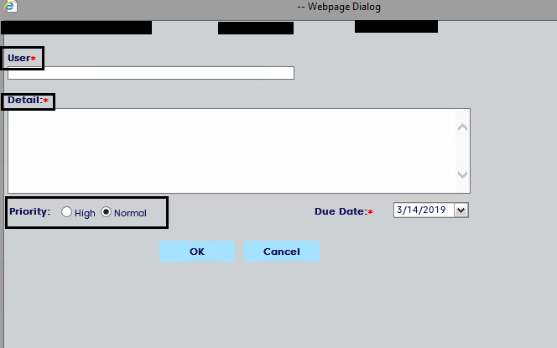

1. Write your message using one of the templates below.

**Documentation Templates**

Once you obtain a status, please document the account using one of the templates below depending on the status and the application type. Please use **only** these templates.

**Unable to Provide Information- DEEM BABY APPLICATION ONLY**

* Called DHHS 1-888-549-0820, Spoke with **XXXXXXX** (rep.’s name). Stated unable to obtain deem baby case status without Mother /Guardian information. Checked in pace 1716 is not scanned. Parents / Guardian information not added in pace. Call Reference- **XXXXXXXMMDDYYYY** (rep.’s first name & date).

**Unable to Provide Information- ALL APP. TYPES EXCEPT DEEM BABY**

* Called DHHS 1-888-549-0820, Spoke with **XXXXXXX** (rep.’s name). Stated unable to obtain application type case status without 1282. 1282 not on file. Call Reference- **XXXXXXXMMDDYYYY** (rep.’s first name & date).

**Pending Additional- Information Needed- ALL APP. TYPES**

* Called DHHS 1-888-549-0820, spoke with **XXXXXXX** (rep.’s name), Stated there is no 1282 form. Unable to obtain claim status. Checked intake and found the same. 1282 was not loaded as per rep. Call Reference - **XXXXXXXMMDDYYYY** (rep.’s first name & date).
* Called DHHS 1-888-549-0820, Spoke with **XXXXXXX** (rep.’s name). Stated **XXXXXXX** (application type) application was received on **XX/XX/XXXX** and it is pending for additional information. 1233 was sent by DHHS on **XX/XX/XXXX**. Evidence needed - **XXXXXXXXX**. Due Date – **XX/XX/XXXX**. **Add here if told any verifications were returned**. Last Caseworker updated note on XX/XX/XXXX. No other outstanding verification. Call Reference - **XXXXXXXMMDDYYYY** (rep.’s first name and date).

**NOT Received- DEEM BABY APPLICATION ONLY**

* Called DHHS 1-888-549-0820, spoke with **XXXXXXX** (rep.’s name). Stated there is no 1716 on file. Unable to obtain claim status. Checked intake and found the same. The 1716 was not loaded as per rep. Call Reference - **XXXXXXXMMDDYYYY** (rep.’s first name and date).

**NOT Received- ALL APP. TYPES EXCEPT DEEM BABY**

* Called DHHS 1-888-549-0820, spoke with **XXXXXXX** (rep.’s name). Stated there is no application on file. Unable to obtain claim status. Checked intake and found the same. Application was not loaded as per rep. Call Reference - **XXXXXXXMMDDYYYY** (rep.’s first name and date).

**Pending- DEEM BABY APPLICATION ONLY**

* Called DHHS 1-888-549-0820, spoke with **XXXXXXX** (rep.’s name). Stated the 1716 was received on **XX/XX/XXXX** and is pending for review. Baby has not been added to mother’s application. Advised to allow some more time. Call Reference - **XXXXXXXMMDDYYYY** (rep.’s first name and date).

**Pending- ALL APP TYPES- EXCEPT DEEM BABY**

* Called DHHS 1-888-549-0820, spoke with **XXXXXXX** (rep.’s name). Stated the **XXXXXXX** (application type) application was received on **XX/XX/XXXX** and is pending for review. Nothing is needed at this time. No checklist has been generated. Advised to allow some more time. Call Reference - **XXXXXXXMMDDYYYY** (rep.’s first name and date).
* Called DHHS 1-888-549-0820, Spoke with **XXXXXXX** (rep.’s name). Stated **XXXXXXX** (application type) application was received on **XX/XX/XXXX** and is pending for VR disability determination. There is no checklist generated. Last Caseworker updated note on **XX/XX/XXXX.** Both 3218 & 921 form on file. No other outstanding verification. Call Reference - **XXXXXXXMMDDYYYY** (rep.’s first name and date).

**Approved- ALL APPLICATION TYPES**

* Approved - Called DHHS 1-888-549-0820, spoke with **XXXXXXX** (rep.’s name). Stated the **XXXXXXX** (application type) application was received on **XX/XX/XXXX** and approved on **XX/XX/XXXX**. Medicaid ID is **XXXXXXXXXXX**. Coverage type is **XXXXXXXXXX** (add type of coverage, if provided). The start date is **XX/XX/XXXX** and ongoing. Caseworker last updated note on **XX/XX/XXXX**. Call Reference - **XXXXXXXMMDDYYYY** (rep.’s first name and date).
* Approved - Called DHHS 1-888-549-0820, Spoke with **XXXXXX** (rep.’s name). **S**tated **XXXXXXX** (application type) application was received on **XX/XX/XXXX** and approved on **XX/XX/XXXX**. Medicaid ID# is – **XXXXXXXXXX.**  Coverage effective from **XX/XX/XXXX** and is ongoing. All dates of visit not eligible. Escalated for retro from **XX/XX/XXXX** is pending. Last Caseworker updated note on **XX/XX/XXXX**. Call Reference - **XXXXXXXMMDDYYYY** (rep.’s first name and date).

**Denied for Lack of Evidence- ALL APPLICATION TYPES**

* Denied - Called DHHS 1-888-549-0820, Spoke with **XXXXXXX** (rep.’s name). **S**tated **XXXXXXX** (application type) application was received on **XX/XX/XXXX** and denied on **XX/XX/XXXX**, due to lack of evidence. 1233 sent by DHHS on **XX/XX/XXXX**. Evidence Needed- XXXXX, XXXXX. (add evidence not on file with DHHS). Due Date- **XX/XX/XXXX**. Last Caseworker updated note on **XX/XX/XXXX**. Call Reference - **XXXXXXXMMDDYYYY** (rep.’s first name and date).

**Denied- Not Disabled- ABD, TEFRA, NURSING HOME, and GENERAL HOSPITAL APPLICATION TYPES ONLY**

* Denied - Called DHHS 1-888-549-0820, Spoke with **XXXXXXX** (rep.’s name. Stated **XXXXXXX** (application type) application was received on **XX/XX/XXXX** and denied on **XX/XX/XXXX**, due to patient not meeting disability criteria. MAO99 came back as not deemed disabled. Last Caseworker updated note on **XX/XX/XXXX**. Call Reference - **XXXXXXXMMDDYYYY** (rep.’s first name and date).

**Denied- Excess/Over Income and Resources- ALL APPLICATION TYPES**

* Denied - Called DHHS 1-888-549-0820, Spoke with **XXXXXXX** (rep.’s name). Stated **XXXXXXX** (application type) application was received on **XX/XX/XXXX** and denied on **XX/XX/XXXX**, due to patient having excess **income** and/or **resources** (select one or both based on what the rep. stated). DHHS found income of **$XXXXX.XX** and/or resources of **$XXXX.XX** (select one or both based on what the rep. stated). Last Caseworker updated note on **XX/XX/XXXX**. Call Reference - **XXXXXXXMMDDYYYY** (rep.’s first name and date).

**How to enter “User Note”**

1. Click on “Application type”

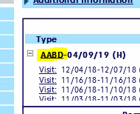

1. In the right corner click on the “sticky note” and type your note
   1. Called SCDHS call center, case pending , received ­­­­­­­­­­­­­­­­­___________ enter date case was received per call center
      1. Add any additional information you can obtain

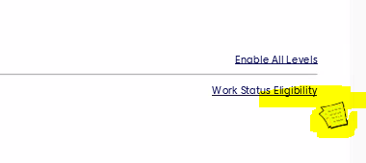

1. Select the message “Private” and “High Importance”

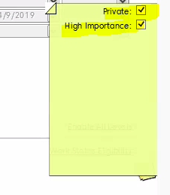

1. Save

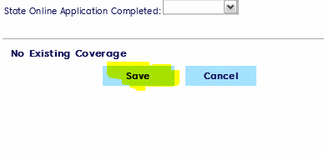

**Patient Queue**

1. Click “*Home*”

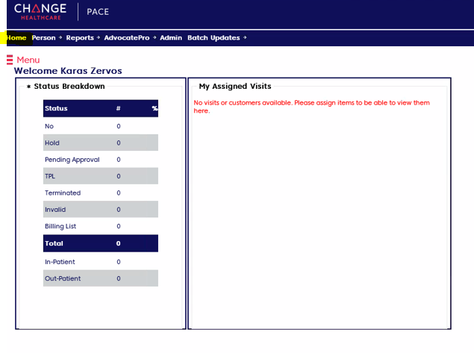

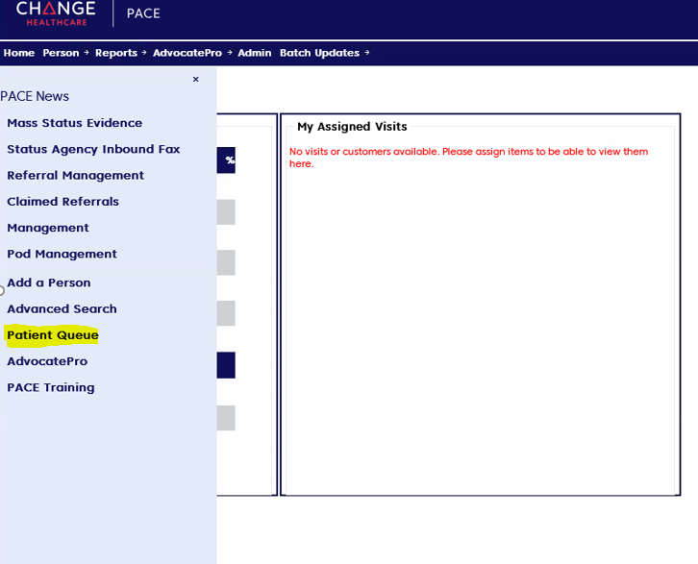

1. The patient Queue will appear

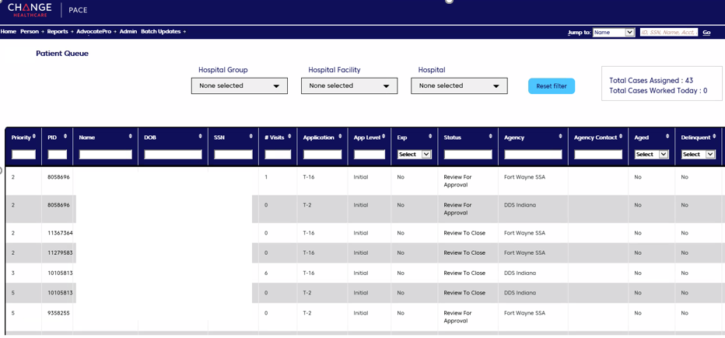

**Resolution Specialist**

**To determine RS name on application:**

1. Click on the name of the application

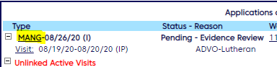

2. Look for RS name listed under application info.

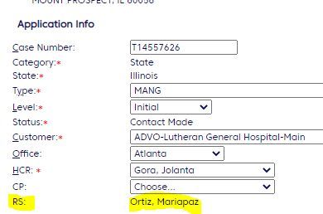

|  |  |  |
| --- | --- | --- |
| **Scenarios** | **Documentation** | |
| **Note Type** | **Message Type** |
| Case Approved | User Task | High |
| Case Denied (first touch) | User Task | High |
| Case Denied (within 30 Days Follow-up) | User Note | High Importance and Private |
| Case Denied (after 30 Days Follow-up) | User Task | High |
| Case Pending | User Note | High Importance and Private |
| Case Closed/Cancelled | User Task | Normal |
| Case Not Found | User Task | Normal |
| Retro Request | User Note | High Importance and Private |
| Case not Eligible | User Note | High Importance and Private |